

Department of Electrical Engineering


A PROJECT REPORT ON
CSV to Graphical Representation

Submitted by
PRN Number | Name of Student
24510052 | Ms.Snehal Jagtap
24510054 | Ms.Kanak Jaiswal
24510059 | Mr.Shreyash Kamthe
24510091 | Mr.Parth Shah

In partial fulfilment of S.Y. B.Tech (Electrical Engineering)
Term work of course
“Minor - Electrical Measurements Lab” [ELMNR302– Sem - III]

CERTIFICATE
Academic Year : 2025-26

This is to certify that the project report entitled “CSV to Graphical Representation”
Submitted by

PRN Number | Name of Student
24510052 | Ms.Snehal Jagtap
24510054 | Ms.Kanak Jaiswal
24510059 | Mr.Shreyash Kamthe
24510091 | Mr.Parth Shah
is a bonafide work carried out by above students under the supervision of Ms. Saba Shaikh & Mr. Sachin Shelar and it is approved for the partial fulfilment of the end semester examination of course “Electrical Measurements” [ELPCC303 – Sem - III] of Second Year B. Tech Electrical Engineering program.

Ms. Saba Shaikh / Mr. Sachin Shelar  Internal Guide  Department of Electrical Engineering | Dr. K. S. Gadgil  Head of Department  Department of Electrical Engineering

Date:
Place: Pune

Abstract

The project “CSV to Graph Representation” focuses on developing an interactive and automated platform that converts tabular electrical data from CSV files into graphical visualizations. This system is designed to help users analyze electrical parameters efficiently by representing numerical data in an easy-to-understand visual form.

The platform supports uploading CSV files that contain various electrical parameters such as phase voltages, line currents, power factors, and power readings. Once uploaded, the system dynamically reads the file headers and plots graphs based on user selection. Users can view single or dual-parameter graphs with clear axis labeling and correct units of measurement.

All timestamps are automatically converted to Indian Standard Time (IST) for consistency. The interface is designed to be simple, responsive, and visually appealing, using an Indian-standard color theme — white background, deep navy blue for charts, and golden yellow highlights.
This project bridges the gap between raw data and meaningful insights, empowering electrical engineers and students to visualize and interpret electrical system behavior more effectively.
❑❑❑

Chapter | Title | Page No.
1 | Introduction | 4
2 | Problem statement and Objective | 5
3 | Software Design | 6
4 | Member worksheet | 7
Table of Contents

Chapter : 1 Introduction

In the field of electrical engineering, vast amounts of data are continuously generated through instruments such as energy meters, sensors, and data loggers. These devices capture critical parameters like voltage, current, power factor, frequency, and energy consumption, which are typically stored in CSV (Comma-Separated Values) format for record keeping and analysis. While this format is efficient for data storage and transfer, manual interpretation of large CSV files becomes cumbersome, time-consuming, and prone to human error. Engineers and students often struggle to extract meaningful insights from tabular datasets without a proper visualization tool.
The “CSV to Graph Representation(CircuitView)” project addresses this limitation by transforming raw numerical data into dynamic, interactive graphical visualizations. By converting complex datasets into clear and well-structured graphs, users can easily identify patterns, observe parameter variations, and detect anomalies over time. This not only enhances understanding but also supports better decision-making in experimental analysis and system performance evaluation.
The developed system employs an automated approach to read CSV files, extract relevant headers, and generate real-time plots based on user selection. It allows comparison between multiple parameters such as voltage and current, while maintaining unit consistency (V, A, kW, etc.) and proper axis labeling. The integration of time-based filters—daily, weekly, or monthly—adds flexibility and precision to data interpretation. Furthermore, the system automatically converts timestamps to Indian Standard Time (IST) to maintain uniformity across all datasets.
By bridging the gap between data collection and visualization, this project promotes efficient data-driven analysis within the domain of electrical measurements. It also serves as a stepping stone for future enhancements involving real-time monitoring, IoT integration, and machine-learning-based trend prediction. Ultimately, this system empowers engineers, students, and researchers to visualize and interpret electrical data more effectively, leading to improved analytical accuracy and operational insight.

Chapter : 2 Problem statement & Objectives

  - Problem statement

Manual analysis of electrical data stored in CSV format lacks efficiency and visualization clarity. Engineers need an automated, interactive solution that can instantly transform raw CSV data into meaningful graphical representations.

  - Objectives

- To design an application that reads and processes CSV files.
- To represent CSV data as dynamic, interactive graphs.
- To allow selection of single or dual parameters for comparison.
- To display correct units (V, A, kW, etc.) on graph axes.
- To implement time-based graph views (Daily, Weekly, Monthly).
- To ensure all timestamps are converted to IST.
- To create a clean, responsive, and visually appealing user interface.

Chapter : 3 Software Design
`

  - Introduction to project

CircuitView is a software-based application that transforms CSV data into visual insights using data parsing, chart rendering, and user interaction modules.

    - Block diagram

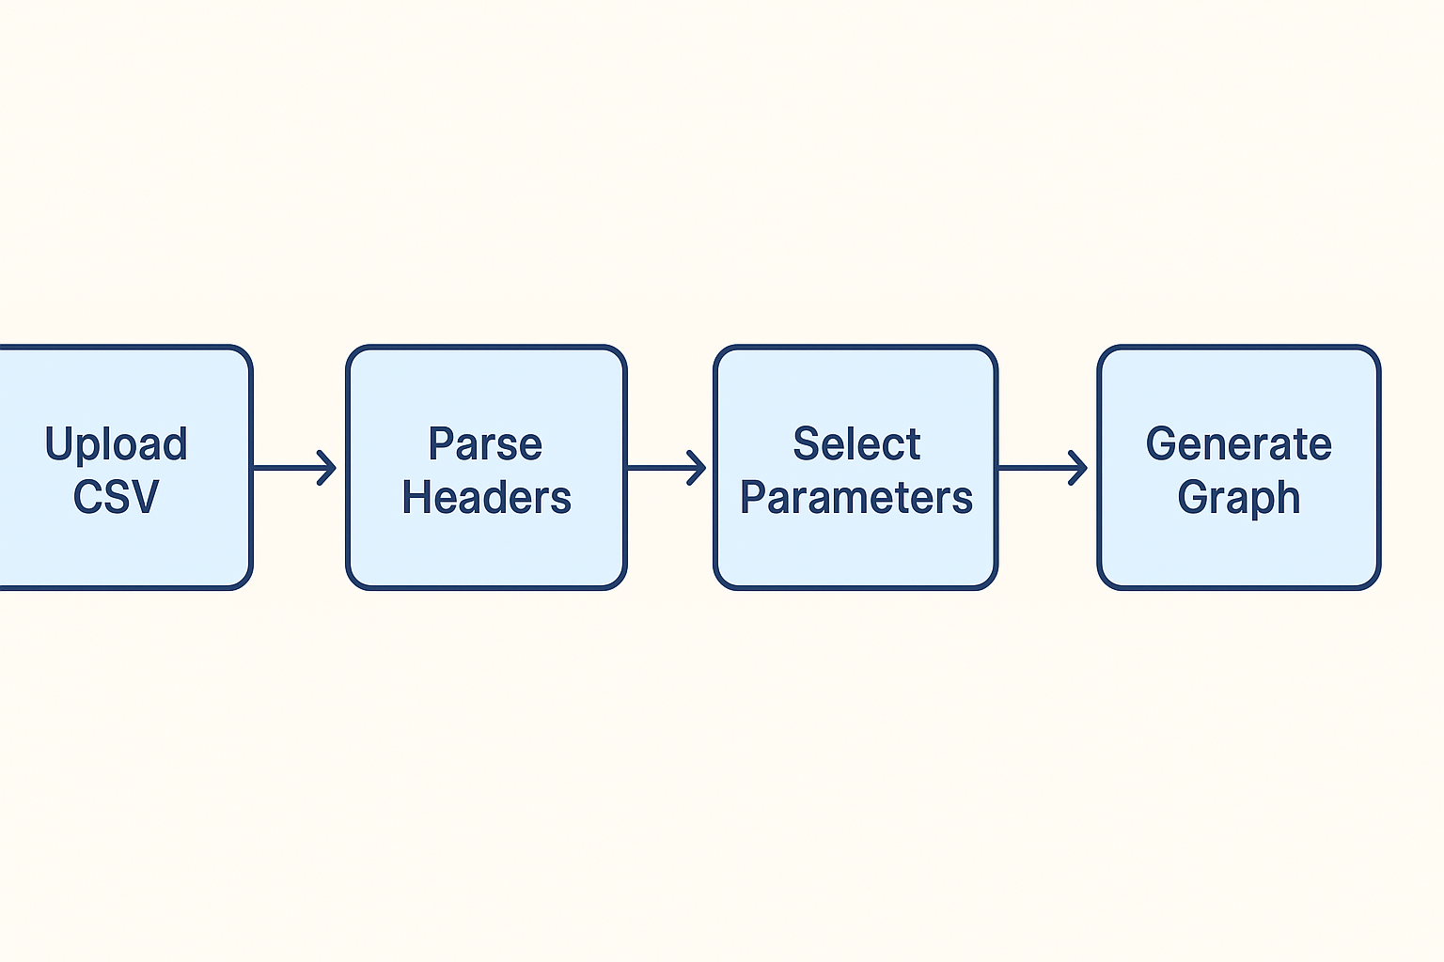

    - Explanation of block diagram
The block diagram of the CSV to Graph Representation system illustrates the sequential workflow involved in transforming raw CSV data into an interactive graphical format. Each block in the diagram represents a major functional stage of the application, as explained below:

- Upload_CSV:
In this stage, the user uploads a CSV file containing electrical measurement data such as voltage, current, or power readings. The file is read through the browser interface and passed to the backend processing system for parsing. The application ensures compatibility with standard CSV formats and validates the uploaded data.

- Parse Headers:
Once the CSV file is uploaded, the system automatically scans the file to identify column headers such as “Time,” “Voltage (V),” “Current (A),” or “Power (kW).” These headers are then extracted and stored as selectable parameters for visualization. This parsing process is performed using a CSV parsing library (e.g., PapaParse) that ensures accuracy and handles variations in file structure.

- Select Parameters:
After parsing, the user is provided with a simple interface to select one or two parameters for comparison. For instance, the user can plot Voltage vs. Time or Voltage and Current together. This feature allows flexible analysis based on the user’s requirements and simplifies understanding of relationships between different parameters.

- Generate Graph:
Based on the selected parameters, the system dynamically generates a graphical visualization using Chart.js or Recharts libraries. The graph includes proper axis labels, legends, and units. Time data is automatically converted to Indian Standard Time (IST) to maintain consistency across datasets. The visualization may be displayed as line, bar, or area charts, depending on the chosen configuration.

- Display Graph:
The final processed graph is displayed on the user interface with interactive features such as zooming, hovering, and tooltips for specific data points.

  - Selection of components
1.Frontend – React.js + TypeScript + Material UI
React.js is used for developing a responsive, component-based interface. TypeScript ensures type safety and reduces runtime errors, while Material UI provides a clean, consistent design for user interaction.
2.CSV Parsing – PapaParse Library
PapaParse is used to efficiently read and process CSV files. It automatically detects headers, supports large datasets, and handles errors or empty lines, ensuring smooth data extraction.
3. Chart Rendering – Chart.js
Recharts or Chart.js are used to visualize data dynamically. These libraries support line, bar, and area charts with tooltips, legends, and axis labeling for better data interpretation.
4. Styling – CSS / Tailwind
Tailwind CSS provides a responsive and lightweight styling framework. It ensures visual clarity with a professional color scheme (white, navy blue, and golden yellow).
5. Hosting – Firebase / Vercel
The project is hosted on Firebase or Vercel, offering fast deployment, scalability, and reliability without the need for a dedicated backend server.

Chapter 4 : Member worksheet

The successful completion of the CircuitView project was the result of consistent teamwork, active participation, and well-coordinated collaboration among all the members. Following table gives the details of the work allotted and completed by each member.

Sr. No. | Member Name | Work done | Sign of other  members
1 | Snehal Jagtap | UI Design, CSV Integration
2 | Kanak Jaiswal | Graph Rendering & Data Processing
3 | Shreyash Kamthe
  Testing, Documentation
4 | Parth Shah | Deployment & Debugging

Throughout the development cycle, all members actively participated in group discussions, brainstorming sessions, debugging efforts, and the final presentation. This collaborative approach fostered creativity, mutual understanding, and a balanced workload, leading to a well-rounded and successful project outcome.

Output

- Dashboard :
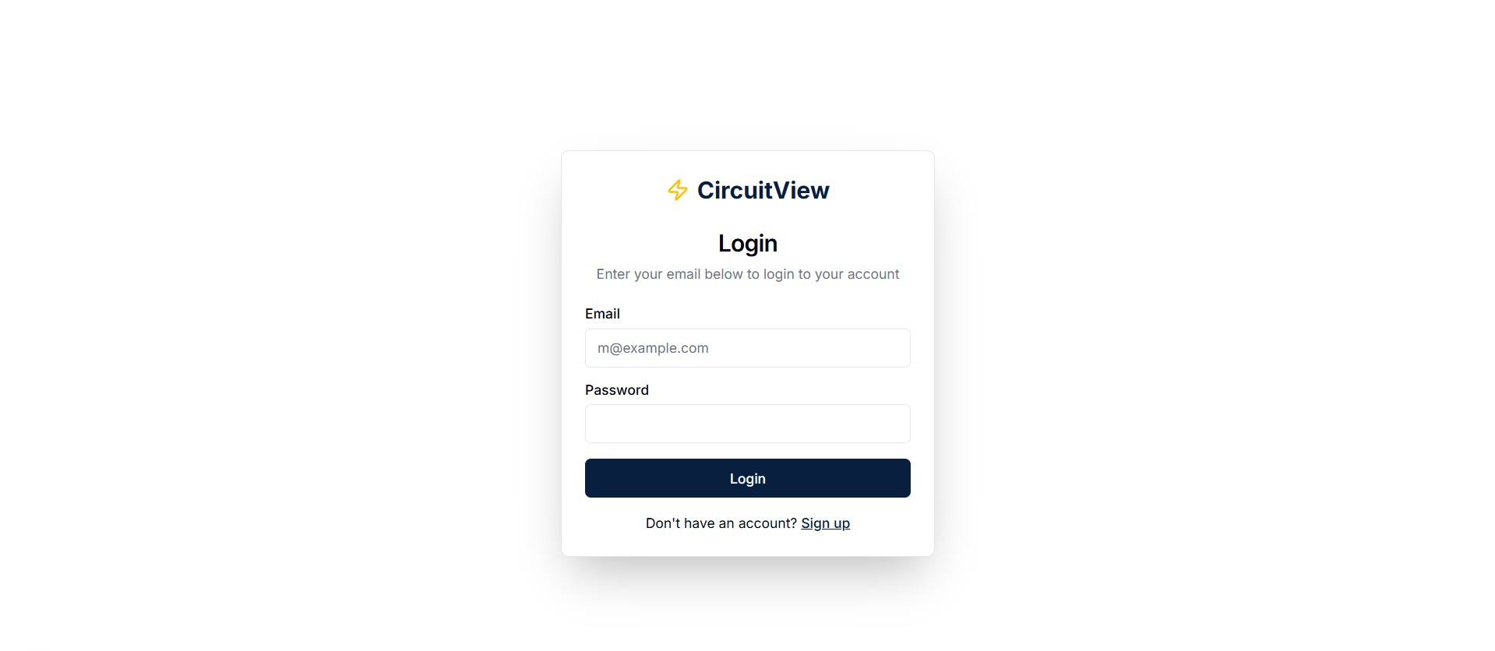
- Light Theme :
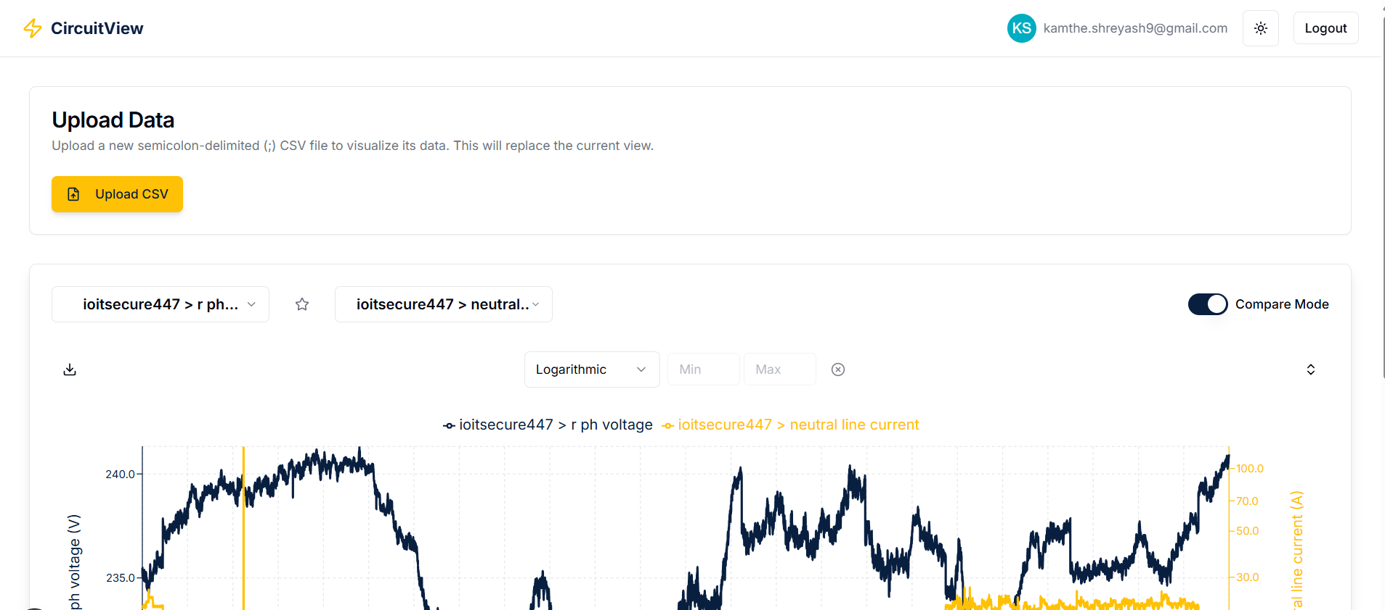
- Dark Theme :
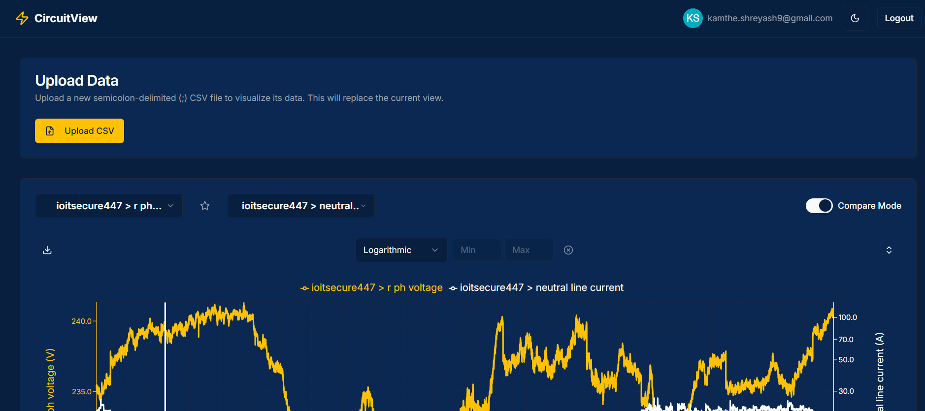

- Graphs & Favorites :
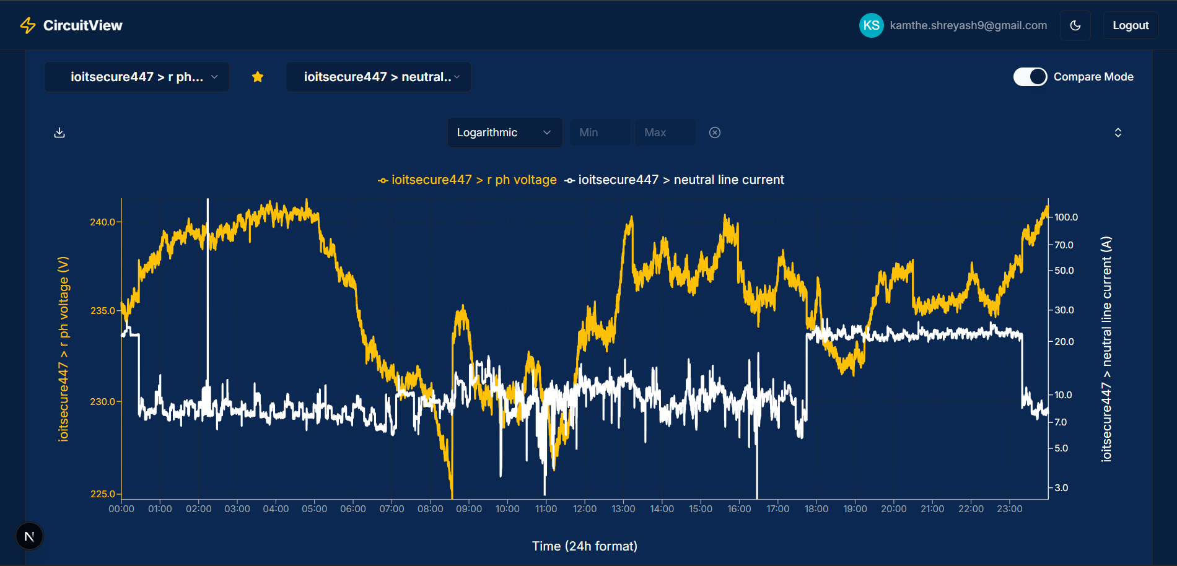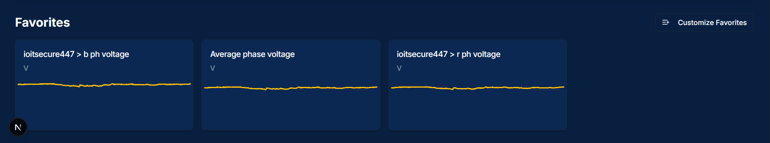

Conclusion

The “CSV to Graph Representation(CircuitView)” project successfully achieves its goal of converting raw electrical data stored in CSV format into interactive and meaningful graphical visualizations. Through the integration of modern web technologies such as React.js, Chart.js, and Firebase, the system enables users to analyze large datasets with improved accuracy, speed, and clarity.

The application eliminates the inefficiency of manual data analysis by automating the process of data parsing, parameter selection, and time-based visualization. It ensures correctness by automatically converting timestamps to IST and maintaining consistent units across all parameters. The user-friendly interface further enhances accessibility for students, researchers, and engineers dealing with real-time or recorded electrical measurements.

This project not only bridges the gap between raw data and analysis but also provides a foundation for future extensions such as AI-based anomaly detection, cloud data synchronization, and advanced analytics dashboards. Overall, it demonstrates a practical, scalable, and educational approach to digital data visualization in the field of electrical engineering.

